**Use Case Overview**

**Use Case Diagram Level 0 :** Income System

**Income System**

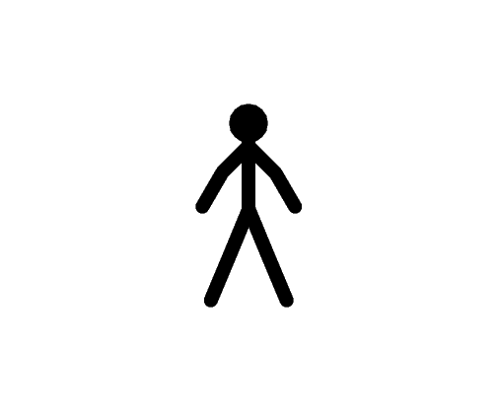

**Sale Management**

**UJ009**

**Sale Employee**



**Income Management**

**Accountant UZ500**

**Use case Diagram Level 1 : Sale Management ( UJ009 )**

Sale Management Sub-System



Sale Product

UJ039

Sale Employee

Send Bill

UJ049

**Use case Diagram Level 2 : Income Management (UZ500)**

Income management

Receive Bill

UZ501



Record Income

Accountant UZ502

Update Income

UZ503